Title: **Numbers and Number Conversion** Test: 2

Course: Introduction to Automation Unit: Introduction to PLC CLO: 4

Name ANSWER KEY Grade 21pts. Date ______________

**Objectives**

1. Student shall describe different types of numbers.
2. Student shall demonstrate the ability to convert numbers from one numeric base system to another.

**Assessment**

Students shall demonstrate a comprehension of the objectives listed above by scoring a minimum of 75% on this Test. Grading shall be based on the answer key.

**Instructions**

Choose the best answer to each of the following multiple-choice questions.

1. A number that has only two states.
   1. Binary
   2. Integer
   3. Float
   4. Word
2. A number that represents a whole number.
   1. Binary
   2. Integer
   3. Float
   4. Word
3. A binary number can be converted to an integer and vise-versa.
   1. True
   2. False
4. Integers can be negative numbers.
   1. True
   2. False
5. A byte has ___ bits and can represent an integer up to _____?
   1. 8, 255
   2. 16, 65535
   3. 4, 128
   4. None of the above
6. Two _______ make a word?
   1. bits
   2. nibbles
   3. bytes
   4. None of the above
7. A _______ can be broken into four words?
   1. nibble
   2. bytes
   3. DWORD
   4. QWORD

Convert the following binaries to decimal

1. 1010 1100 172
2. 0011 0100 52
3. 1100 1001 201
4. 0110 1011 107
5. 1111 0101 245

Convert the following decimals to binaries.

1. 112 0111 0000
2. 43 0010 1011
3. 59 0011 1011
4. 255 1111 1111
5. 191 1011 1111
6. 100 0110 0100

Circle the following addresses in the appropriate table.

1. 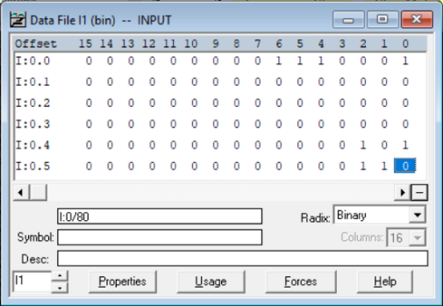O:0.0/3
2. I:0.1/5
3. 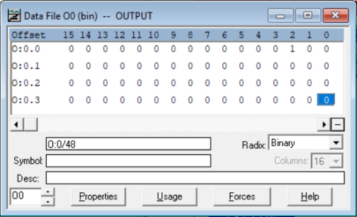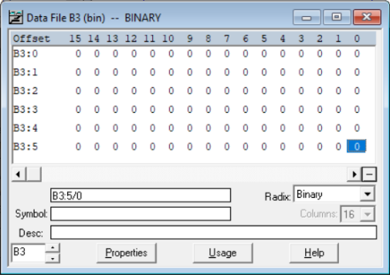B3:2/5